Name – Shanuusree M
Reg No – 192412319
A. TE10 Mode Simulation: A WR-90 rectangular waveguide has a = 22.86 mm, b = 10.16 mm and length L = 100 mm. Operate it at f = 10 GHz and excite the dominant TE10 mode in HFSS. Obtain the E-field and H-field distributions, simulated cutoff frequency fc and propagation constant β. Calculate fc (theory) = c/(2a), β = (2πf/c)√[1−(fc/f)²], and the percentage deviation of simulated fc from theoretical fc.
OBJECTIVE:
To develop electromagnetic simulation models for TEM, TE and TM propagation modes in suitable microwave transmission structures.
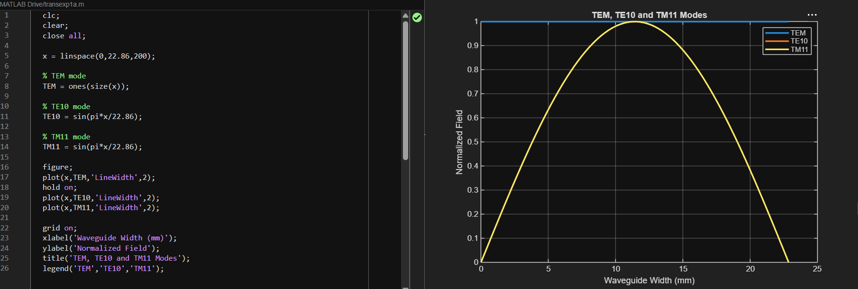

To visualize and analyze the electric-field and magnetic-field distributions associated with different propagation modes
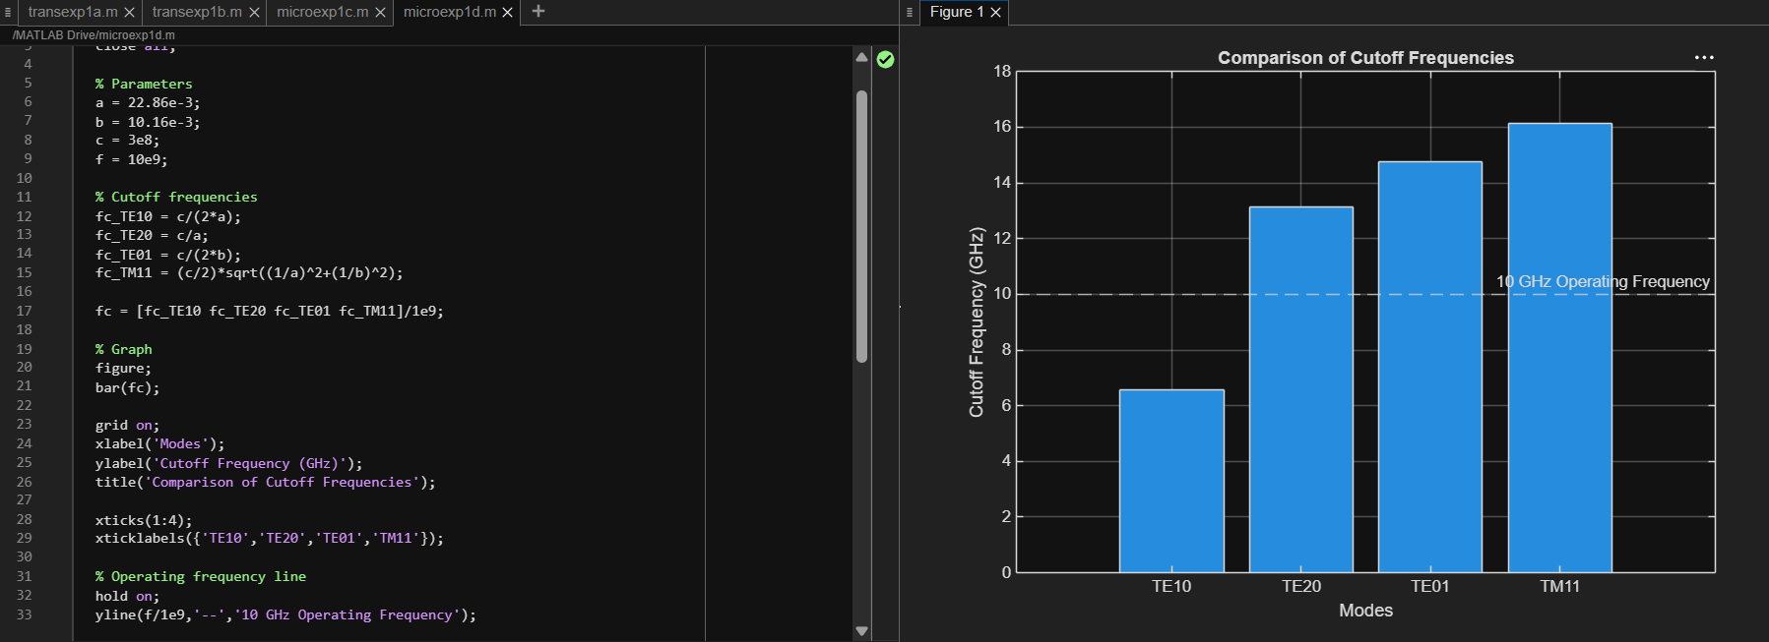

To determine the cutoff frequency, propagation constant and field characteristics of selected TE and TM modes.
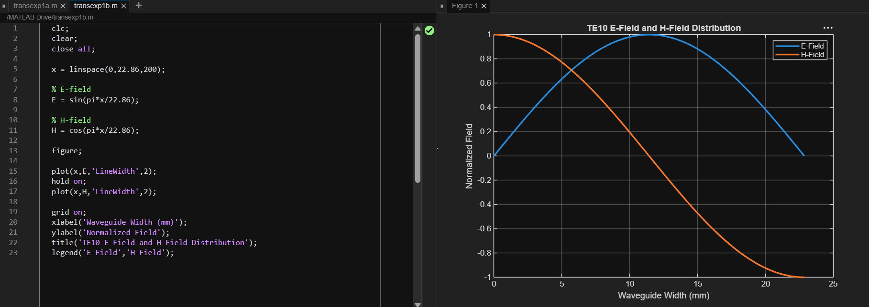

To compare the propagation behavior of different modes and identify their suitability for practical microwave transmission.
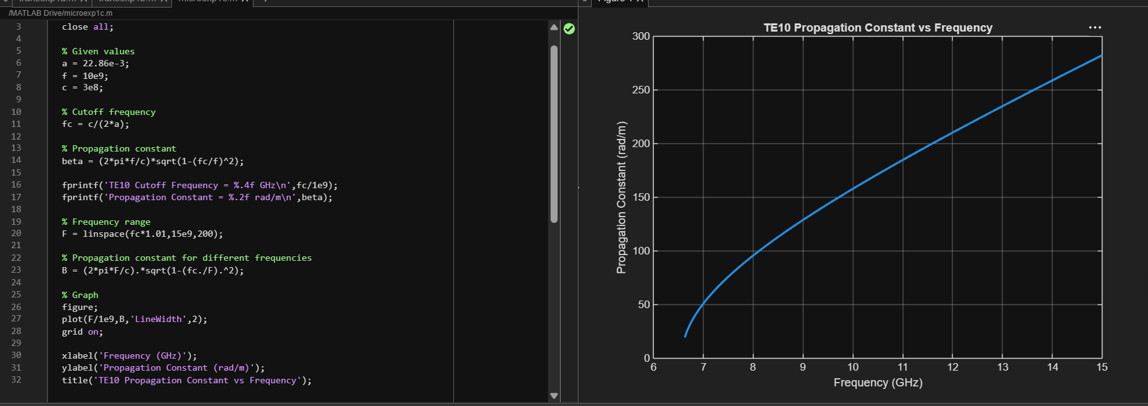

B. TE10 versus TM11: Using the same WR-90 waveguide at f = 10 GHz, simulates both TE10 and TM11 modes. Determine fc, β and the E/H-field distributions for each mode. Calculate the theoretical cutoff frequencies using fc(mn)=c/2√[(m/a)²+(n/b)²]. Compare the results and justify why TE10 propagates at 10 GHz while TM11 does not.

OBJECTIVE:
To develop electromagnetic simulation models for TEM, TE and TM propagation modes in suitable microwave transmission structures.
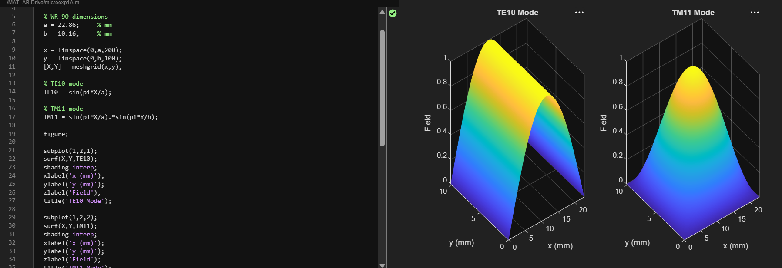

To visualize and analyze the electric-field and magnetic-field distributions associated with different propagation modes.
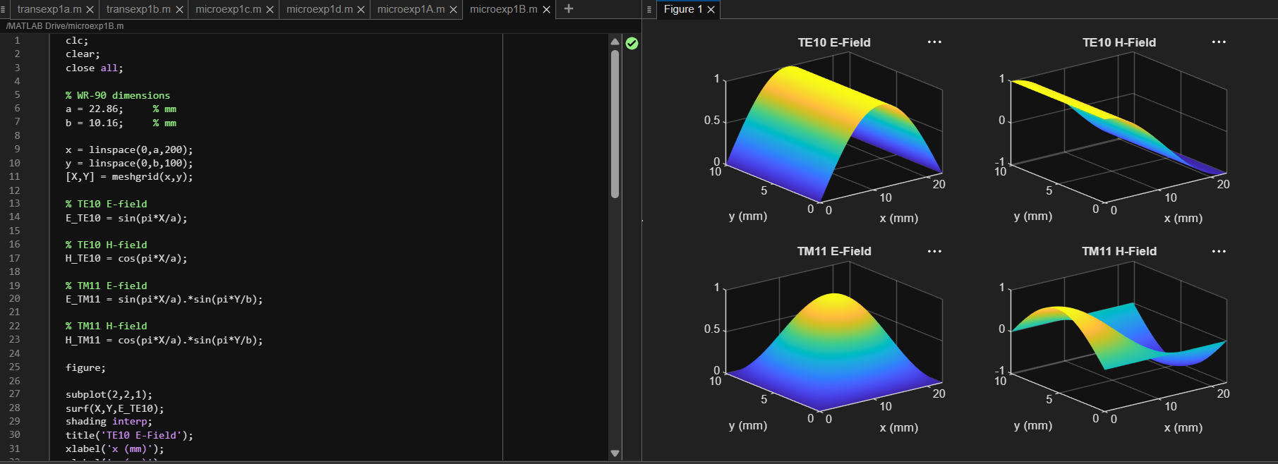

To determine the cutoff frequency, propagation constant and field characteristics of selected TE and TM modes.
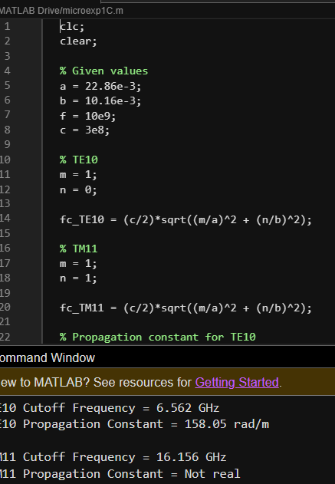

To compare the propagation behavior of different modes and identify their suitability for practical microwave transmission.
